Reference Manual
SteelCE

Introduction 3
General Notes 3
General Information  3
Keyboard  3
Used KEYS 4
Using the Application 5
OrganiZation AND LAUNCHING THE application 6
SteelCE général Présentation 7
DATAS MENU 9
PROFILES MANAGEMENT 9
MATERIAL GRADES MANAGEMENT 10
Configuration Menu 11
Post-processOr 11
Application 15
LangUage 17
Importation 17
programmING 18
Header creation 18
Drillings creation 19
Hole MATRIX 22
circular drilling 23
IMPORTATION 24
Importation 24
Components visualization 25
Parts MANAGEMENT 29
UNSELECT 29
DELETE 29
ONe by one selection 29
Multi Selection et filtER 29
EXECUTION 31
Processing the selected parts 31
Main SCREEN 32
X or Y AXIS ZOOM 35
sub programs 36
Maintenance 37
Parameters 39
GraphiC 41
Alarms history 42
Alarms 43

Introduction

General Notes

SteelCE software is a self-contained application operating under Windows environnment and is dedicated to the FICEP drilling line with FANUC NC.

SteelCE is an obligatory crossing for the production organization. This package was developped on the ground of many year experience, in order to solve the real workshop problems.

General Information 

The following paragraphs describe some general conventions used in this manual for SteelCE to facilitate the interactive dialogue between operator and computer.

It is of fundamental importance to distinguish between the figure "0" from the capital letter "O"; the figure "1" from the letter "I", that could generate errors.
In this manual, the decimal point replaces the decimal comma.

Keyboard 

In this manual, the keys used for the dialog with the computer will bu put into brackets […]. Validation key RETURN will be symbolized as [RETURN].

ECHAP or ESC key will be symbolized as [ESC].

The function keys (Keyboard tob ) could be symbolized by [Fxx] where xx represents values from 1 to 12.
For example [F10] means " press the function key F10 "

Function [Alt-A] means " Push ALT key then « A ».

Words CN or CNC mean Numerical Command.

Used KEYS

The CN keyboard is provided by GE-FANUC. This keyboard is using special symbols. You can find in the following table the equivalent to a standard keyboard :

[ENTER] Validation, Enter

[FlG] ➔ Left Arrow
[FlD] ⬅ Right Arrow
[FlH] ⬆ Up Arrow
[FlB] ⬇ Down Arrow

[PgUp] Page Up

[PgDn] Page Down

[Ins] Insertion Mode


[Del] Delete


[BkSp] BackSpace

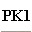
[Ctrl] Control

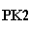
[Altl] Alt

[Tab] Tab

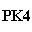
[Esc] Escape


[Esp] + M Space.

[/] + C Slash

[\] + S Back Slash

Using the Application

The use of this application can be subdivided into 2 categories :

Moving in the menu .
Moving in the program .

The menu contains elements that are not used often by the operator such as the configuration of the application.

Moving in the Menu

To access the menu, press [ALT] 2 times (PK2). The selection bar opens the first available menu item. The next move can be made using the direction arrows.

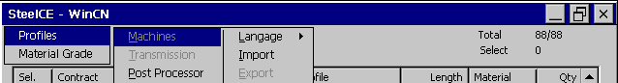 Menu

Moving into the lists can be made using the arrows.

Moving in the program

[FlG] ➔ Left Arrow
[FlD] ⬅ Right Arrow
[FlH] ⬆ Up Arrow
[FlB] ⬇ Down Arrow

To access to the commands of the application, you should use the function keys [F1] to [F10].

OrganiZation AND LAUNCHING THE application

Directories used
\\STORAGE CARD\STEELCE\

FANUC : Automate, CNC Configuration, Communication Programs

ISO : CNC Sub programs

IMPORT : Default directory for CAM files Import.


The program SteelCE is automaticaly launched at the start of the computer. You may also use the shortcut available on the desktop.

SteelCE launch screen contains the following informations :

Launching the application

- Ficep serial number and name of the costumer.
- GE-FANUC serial number
- Steel Projects softwares and options

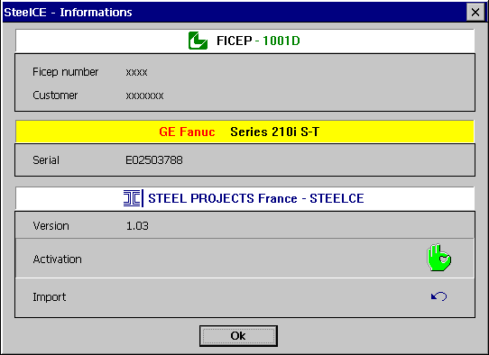
SteelCE launch screen

SteelCE général Présentation

The main screen of SteelCE is made of a list of parts and the commands related to these parts, so that you can select or unselect components to delete or to execute them. You can also visualize many aspects of the components such as Zoom, Graphic or generated Program. You may also be able to create or to import new parts.

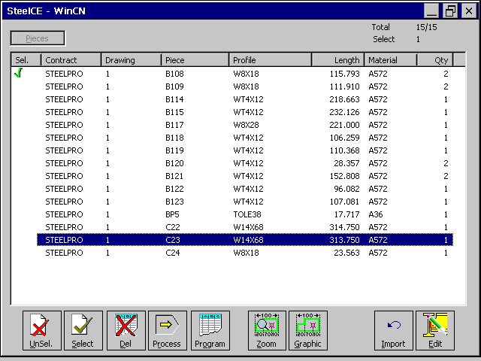
SteeCE Presentation

Unselect all parts

Commands definition

Select and Filter parts

Delete selected parts

Execute selected parts

Cam file of the highlighted part

Graphic Zoom List mode

Gaphic of the current part

Parts import (CAM files)

Input or modification of a part

DATAS MENU

SteelCE allows the user to create new parts, as it will be detailed in the next chapter. For that we need a user database containing informations about the profiles and the material grades.

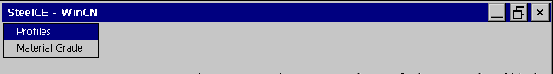
Data sub-menu

PROFILES MANAGEMENT

The creation of a part will be validated only if the profile of this part already exists in the database.

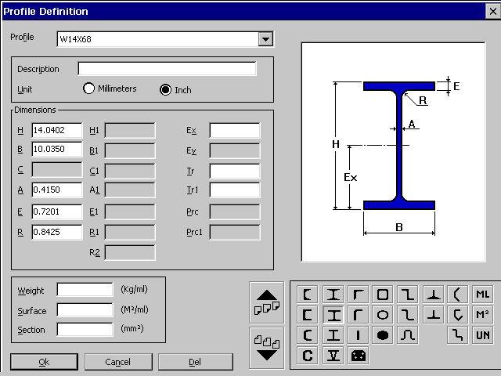Profiles management

The profiles concerned are divided into categories. Each category is represented by an icon.

By choosing an icon, you can have access to all the profiles in the corresponding category that the database contains.
To change the category, the keys [PgUp] and [PgDn] are used.

The software only autorizes the update of information related to the current category. All other informations are disabled.

- Choose a category.

STEPS FOR THE CREATION OF A PROFILE
- Type in the profile name in the related field.
- Select the unit of your profile(i.d. Millimeter of Inches).
- Input the different dimensions of the profile.
- Validate with [OK]

- Choose a category.

DELETING A PROFILE
- Type in the profile name or select it into the list.
- Delete using [SUPPR.]

MATERIAL GRADES MANAGEMENT

The material grade is an option when creating a part.It just stans as an informative data. You can create or delete material grades in the following window :

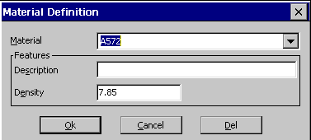
Material grades management

Configuration Menu

This sub menu allows the program to have all its configuration’s parameters being configurated.

Before proceeding to any modofication in the configuration, we advise you to proceed to the necessary backup of the previous configuration, to avoid the possible loss of data.

NB : Please avoid to modify parameters that are not described in this manual, as they could cause pertubations in the good working of the machine.

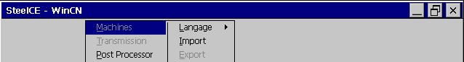
Configuration Menu

Post-processOr

This menu allows to modify the parameters used for the creation of the executable program.

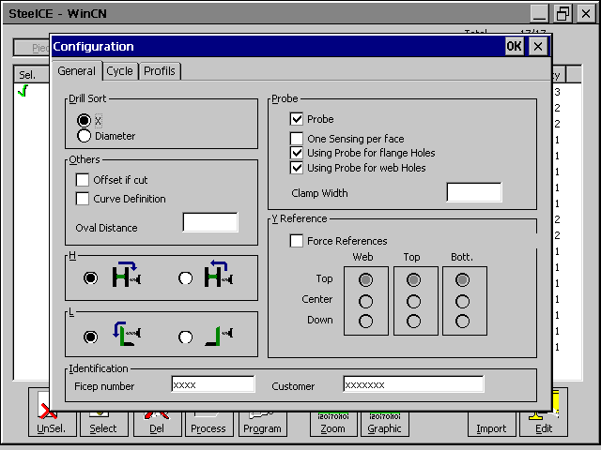

General
Configuration Post Processor - General

Drill Sort | X : Process of the tooling sorted by growing X dimension.  Diameter : Process of the tooling sorted by growing diameter.
Offsert if cut | Automatic calculation of the offset on the X-Axis after the referencing of the part in the case of a non straight cut.
Curve definition | Allow to recalculate the tooling after the affectation of a curve to a component.
H | Profile rotation mode.
L | Angle rotation mode.
Probe | Using Probe .
Y Reference | Force the probe reference for each side.
Identification | Costumer and machine identification

This screen allows to modify the cycle’s parameter for the execution of the parts.

Cycle

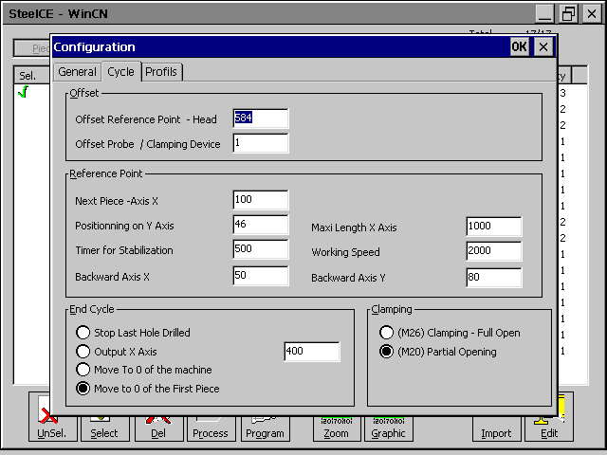
Configuration Post Processor - Cycle

Profiles
In this screen you can modify :

- The profiles accepted by the machine.
- The authorisation for rotations of the profiles in each category
- The default rotations for each category.
- Execution origins for each category.

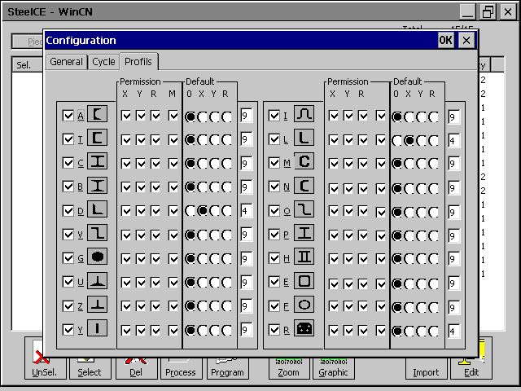
Configuration Post Processor - Profiles

Application

This menu allows to modify the parameters of the application.

In this screen you can modify the directories where the application can find the database and the components.

Application

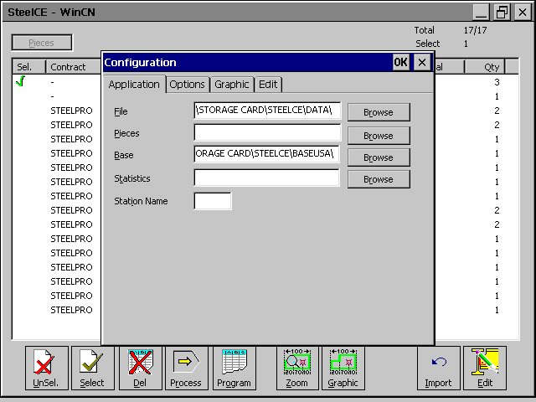
Application’s configuration - Application

File | Directory for the user file (contract …)
Base | Directory for the database

Editor
This screen allows the user to modify the editor’s parameters for the creation of a new part.

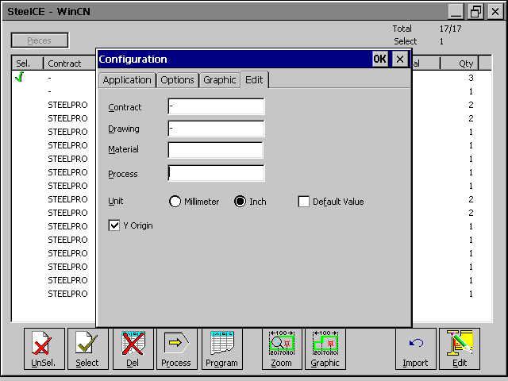
Application’s configuration - Editor

Contract | The “Contract” field is automatically filled for each new contract.
Drawing | The “Drawing” field is automatically filled for each new component.
Material Grade | The “Material Grade” field is automatically filled for each new component.

Process | Not used in SteelCE.
Unit | Mm : Choice of mm as default unit.  Inch: Choice of inches as default unit.  Defaut Value: The user has to take the default unit.
Y Origin | Possibility to change the Y origin for the tooling editor.

LangUage

This option allows to choose tha language of the application. Just select the desired language, and all the menus and messages will be transalted.

Importation

You have here the possibility to create import for the application. In SteelCE, you can only import “CAM” files

The CAM import is already in the application as a default value. The default directory for the “CAM” files is « \\Storage card\SteelCE\Import\*.cam ».

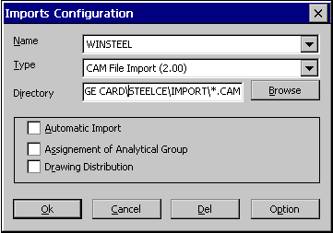
Imports configuration

programmING

SteelCE allows the creation of new components. This fonction is available from the list of parts and the command [F10].

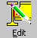
[F10] Allows to create new parts if the cursor is on an empty line, or to modify the selected part where the cursor is.

Header creation

SteelCE gives default( that you can setup in the parameter menu) for contract, drawing and material grade.

The creation of a new part would be efective once the information of its header are validated. (Contract, Drawing, Piece, Profile, Length, Quantity and Material Grade).

The new component can be part of a contract and/or drawing already existing. For that you can select one in the list.

All the fields in the header have to be filled except the material grade. The fields Profile and Materail Grade are subject to database check.

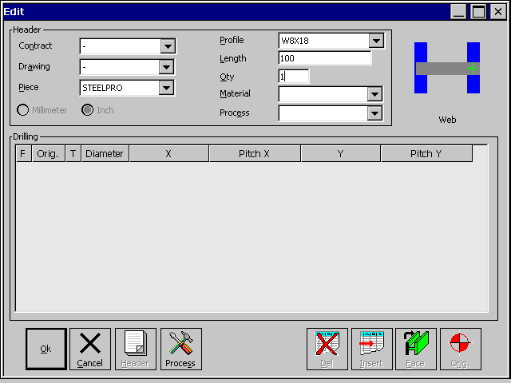
Header Creation

Commands definition

Validation of the header, and go back to the parts list.

Back to the parts list.

Validation of the header and input of toolings.

Drillings creation

At the validation of the header, you can see a graphic of the part created, and the drilling editor.

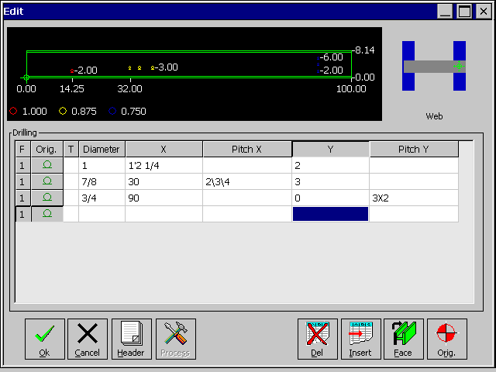
Drilling creation

Definition of the columns :
Column | Function
F | Side of Profile (1=Web, 2=Top Flange., 3= Bottom Flange)
Origin | Low Origin (Positive Gauge)  High Origin (Negative Gauge)  Centered Origin (Positive and Negative Gauge).
T | Type drilling group M = Matrix / C = Circular
Diameter | Diameter of drilling (diameter = 0 ➔ pointing)
X | Absolute coordinates for X Axis.
Pitch X | Relative coordinate compared to the last X Value
Y | Absolute coordinates for Y Axis.
Pitch Y | Relative coordinate compared to the last Y Value

NB : If a column is empty, SteelCE seeks the informations in the columns above.

In the columns “Pitch X” and “Pitch Y”, the following separators are accepted :

- « \ » or « + » : Separator of relatives coordinates
- « X » or « * » : Multiplicator of relatives coordinates
- « / » : Inch fraction
- « ‘ » : Foot definition

To define coordinate : Foot_Value[’]Inch_Value[Space]Fraction_Value
Example : 5’ 2 1/4

Drillings validation

Commands definition

Back to components list

Back to header

Delete a drilling.

Inserting a drilling.

Side change.

Change of Y origin.

Drilling examples

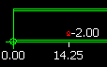
Row 1 :
F | Orig | Dia | X | X Pitch | Y | Y PitchY | Comment
1 | Low | 1 | 1’2 1/4 |  | 2 |  | Hole :  Web / X=14.25 Y=2 / Diam 1

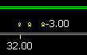
Ligne 2 :
F | Orig | Dia | X | X Pitch | Y | Y Pitch | Comment
1 | Low | 7/8 | 30 | 2\3\4 | 3 |  | Holes:  Web / X=32 Y=3 / Diam 7/8  Web / X=35 Y=3 / Diam 7/8  Web / X=39 Y=3 / Diam 7/8

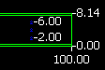
Ligne 3 :
F | Orig | Dia | X | X Pitch | Y | Y Pitch | Comment
1 | Low | 3/4 | 90 |  | 0 | 3X2 | Holes:  Web / X=90 Y=2 / Diam 3/4  Web / X=90 Y=4 / Diam 3/4  Web / X=90 Y=6 / Diam 3/4

Hole MATRIX

It is also possible to create holes by using a matrix. This leads to the creation of a group of holes.

To use this option, you should type “M” in the column type of drilling( T ).

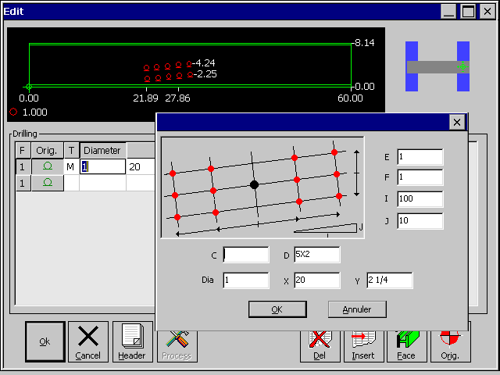
Hole Matrix

Field | Description
Dia | Holes diameter
X,Y | Coordinates of the origin of the group.  No hole will be created there
C,D | Relative horizontal coordinates of the holes.  C= Hole on the left of the starting point  D= Hole on the right of the starting point
E,F | Gauges or vertical coordinates of the holes.  Same syntx as D
I,J | Triangulation for the calculation of the angle  I=1, J=0 means angle = 0.

circular drilling

It is also possible to create drillings using a circular matrix. Here also you create a groupe of holes.

To use this option, you should type “C” in the column type of drilling( T ).

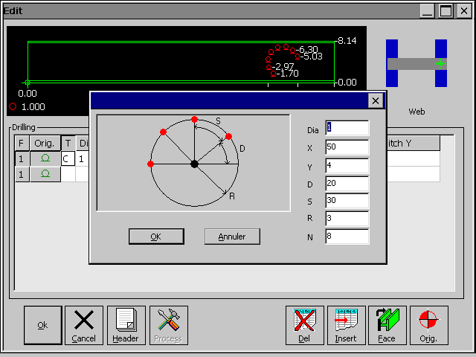
Holes CircularMatrix

Field | Description
Dia | Holes diameter
X,Y | Coordinates of the origin of the group.  No hole will be created there
D | Starting angle
S | Angle of one sector
R | Radius of the group of holes.
N | Number of holes to create.

IMPORTATION

SteelCE can import files that are in CAM format (the Steel Projects standard format). This depends on the options you have purchased with the software. To use this function you have to press [F9].

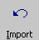
[F9] allows you to import files into SteelCE (Only Steel Projects CAM files).

To import files in DSTV, DXF or any other format, Steel-Projects will provide you a converter (WinCONV) to be installed on a computer equiped with Win95, 98, NT, 2000 or XP, to convert those files into CAM. You can also use WinSTEEL to do that.

Importation

SteelCE shows all the files available to import, according to the parameters you have set up in the configuration. All the files in the select window will be imported when [OK] is pressed.

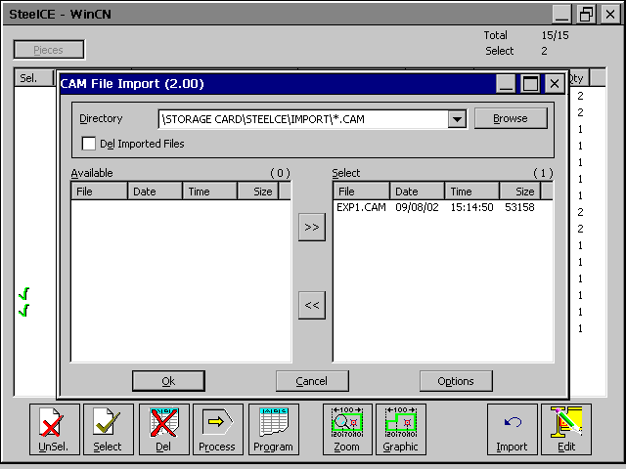
CAM Files Importation

Components visualization

SteelCE allows you to visualize the components using a Zoom or a Graphic. These features are available from the parts list, by using [F6] or [F7]. It is also possible to visualise the CAM associated to the part by using [F5].

[F6] allows you to visualize the parts drawing but lets navigate into the parts list.This allows to see the parts for having better details when selecting them.

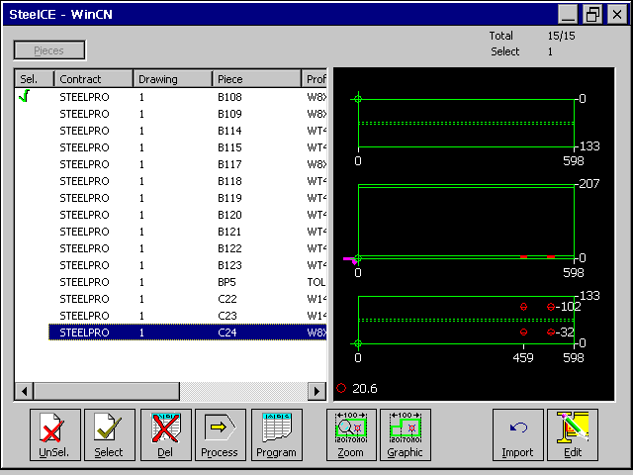
Pieces list in Zoom Mode

To go back to the parts list without zoom, push [F6] again.

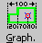
[F7] Allows you to visualize the drawing of a part. You also have the possibility to zoom into that drawing to see details of it.

Two function are available to change the scale (ZOOM) and two other to move the component (PAN).

[PAN LEFT] ➔ Left arrow
[PAN RIGHT] ⬅ Right arrow
[ZOOM IN] ⬆ Up arrow
[ZOOM OUT ] ⬇ Down arrow

[ZOOM MAXI ] Page Up
[ZOOM MINI ] Page Down

Commands definition
Validate the modifications.

Back to parts list.

Marking ( Not used in SteelCE )

Origin change.

Symetry on X and Y axis.

Parts Rotation.

90° Rotation (Not used in SteelCE ) .

Back to the default position.

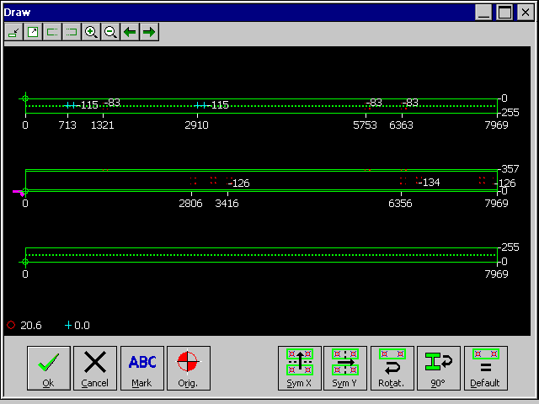
Part graphic

[ZOOM IN] ⬆ Up arrow
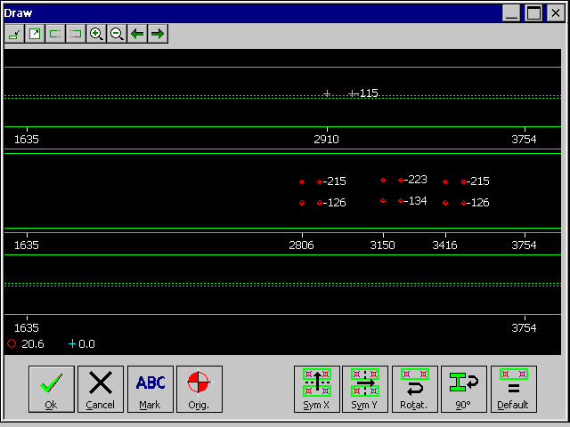
Part grapjic after zoom in
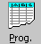
[F5] allows you to visualize the program of the component in the Steel-Projects CAM format.

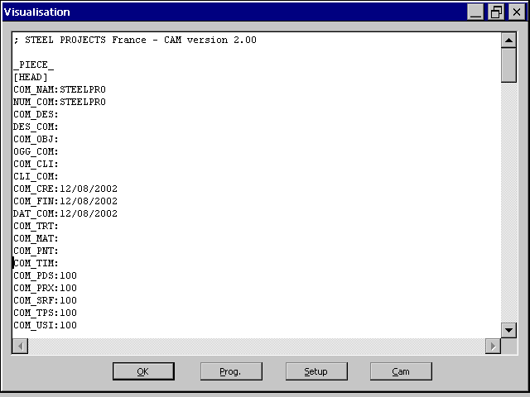
Part Cam file

Parts MANAGEMENT

SteelCE allows you to select one or some components to download them to the memory of the machine, or to remove them from the database. These functions are available from the parts list by using [F1] or [F2].

The selected parts are signaled by the following sign at the beginning of the row.
There is 2 method to select parts. The first is a one by one selection, the other one is amultiple selection.

A counter indicating the number of parts selected and the number of parts available is displayed at the top right corner of the window.

87 : Total number of parts in SteelCE
26 : Number of parts that can be viewed in SteelCE. The other 61 parts does not meet the filter setup.
- : Number of selected parts.

UNSELECT


[F1] allows to unselect all the currently selected parts.

DELETE


[F3] allow after validation to delete all the selected parts.

ONe by one selection
The one by one selection and unselection is made using this key :

Multi Selection et filtER


[F2] allows to select and filter parts according to the criteria you enter.

The button [ RAZ] allow to reset both the selection and filter.
Sélection : All the components from the list that will meet the criteria will be selected.
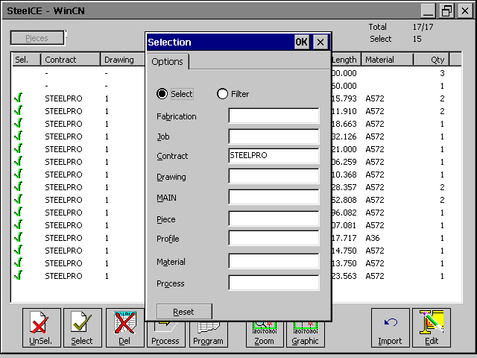
Parts selection

Filtre : Only the components meeting the criteria will be displayed into the list.
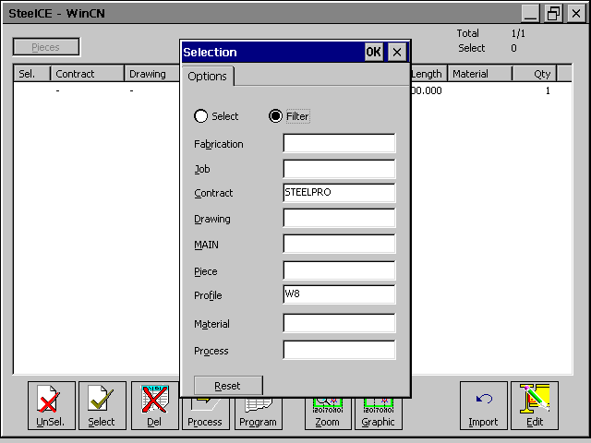
Parts filter

EXECUTION

This function first reminds you the selected parts, creates the executable program for the machine and then downloads them for execution. You can then follow the execution of the part

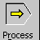
[F4] allows to send the selected files to the machine.
If no parts are selected, it launches the execution mode, without sending any file to the machine.

Processing the selected parts

After you required a processing for parts, the following screen appears.

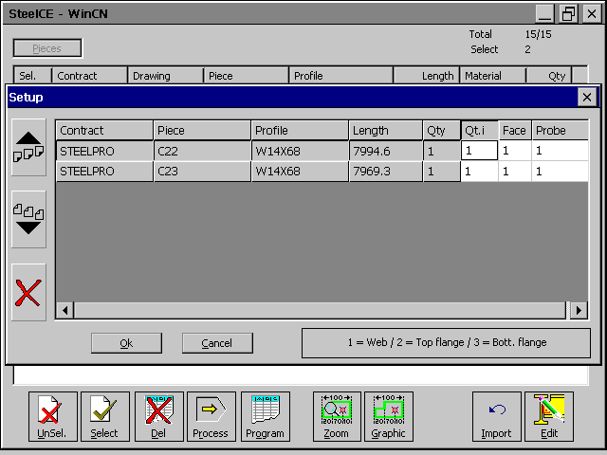
Processing the selected parts


Move part to the superior rank.

Move part to the inferior rank.

Delete the part.

Ok | Validation
Cancel | Back to parts list

The key [ENTER] pushed on a component allows you to change the quantity to produce and to choose the side to be processed.
- 1 = Web
- 2 = Top Flange
- 3 = Bottom flange

Main SCREEN

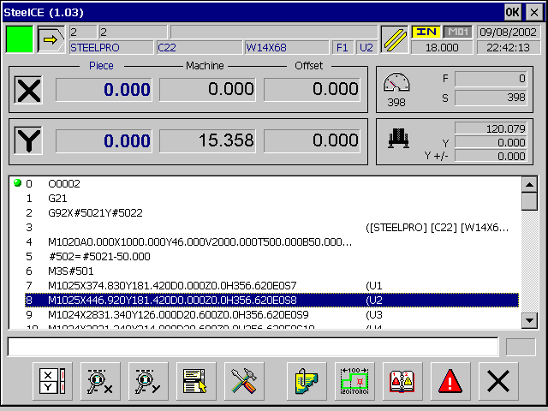
Execution Mode – Main Screen
The main screen allows you to visualize the current program, the state of ht emachine, and the values of the different axis.

State of the CNC.

State definitions

Working mode of the CNC.

Sequence / Program / Comment.

Unit.
Optionnal
Stop

Current Contract / part / side / Hole.

State of the program.

Current Diameter .

Back to default position.

Speeds display :
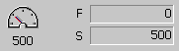
F : Linear speed
Y : Required value / Real value

Probe management (Optional) :
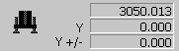
: High value of the probe
Y : Corrected Y coordinate.
Y+/- : Correction on Y.

Current Program :
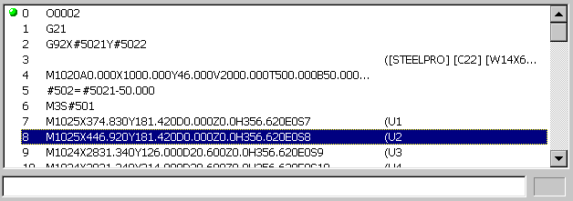

the green dot shows the current executed line in the program.

Commands Definition

X and Y axis display.

X and Y axis zoom.

Sub programs access

Maintenance screen access

Parameters screen access

Graphic of the current part

Alarms history

Current alarms

Quits execution mode

X or Y AXIS ZOOM

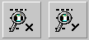
[F2] et [F3] allow to visualize one axis in zoom mode, and to move it manually.

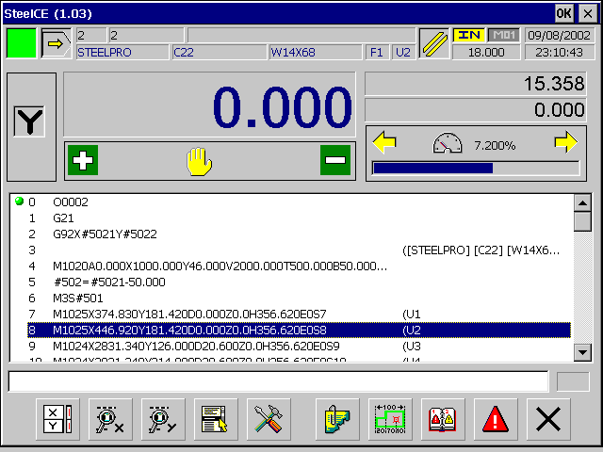
Execution Mode – Zoom on Y axis

In manual mode, the user can move an axis with the key from the operator’s keyboard and change the speed using the arrows [←] and [→] from the keyboard.

sub programs


[F4] allow you to executemanual sequences on the machine.

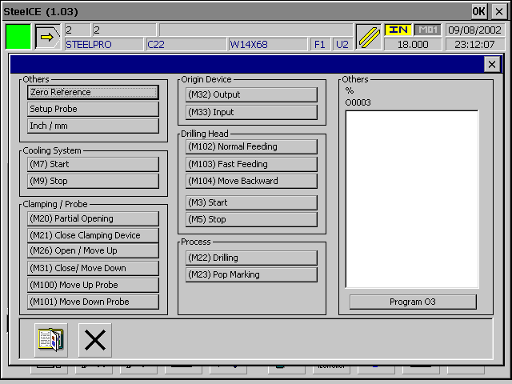
Execution Mode - Program

After the selection of the program, it is automatically loaded into the memory and can be executed in the same way as a part’s program.


The button allows to load into memory the last part’s program generated.

Maintenance


[F5] allows to visualize the current cycles of the machine. In real time, the operator can follow the main operations of the machine, the state of the inputs and outputs and of the temporisations.

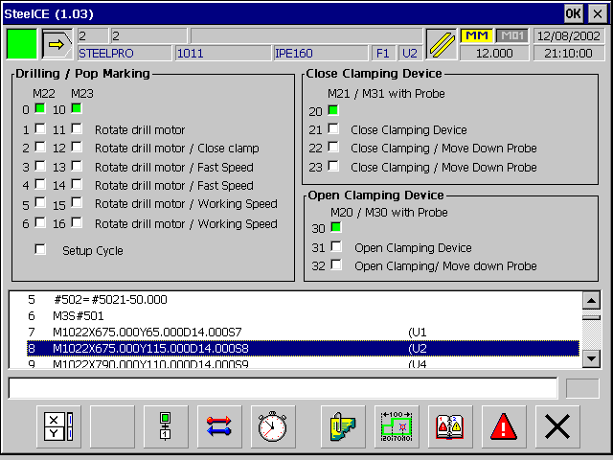
Execution Mode – Maintenance - Cycles
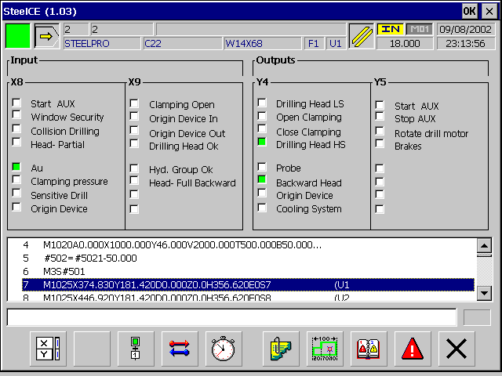
Execution Mode – Maintenance – input and output

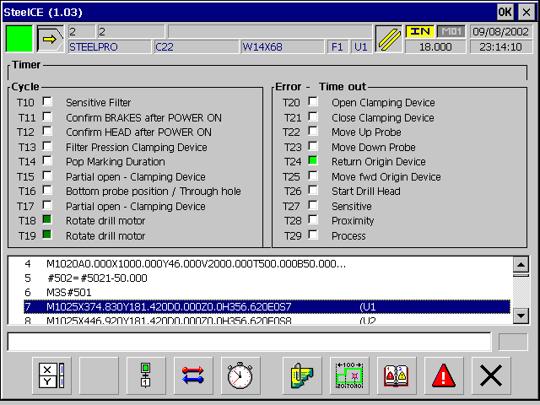
Execution Mode – Maintenance - Temporisations

Parameters


[F6] allows to modify the parameters of the application.

Definition of speed of rotation according to the diameter
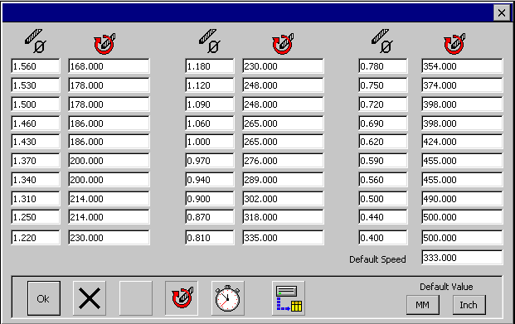
Execution Mode – Parameters – Speed of rotation

Temporisations definitions:
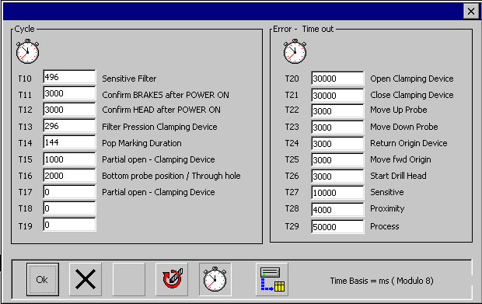
Execution Mode – Parameters –Temporisations
Parameters definition and services of the application
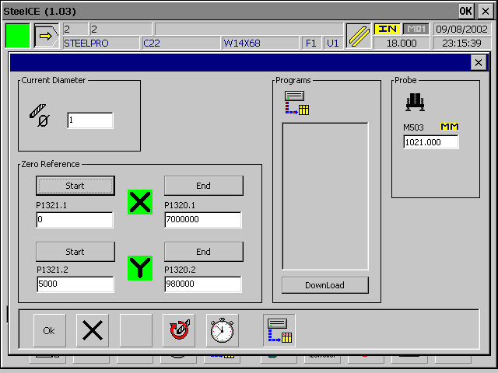
Execution Mode – Parameters – Services

Functions
Diameter | Input of the current diameter on the machine
Transfert | Application’s sub programs modification
Start X | Start the referencing sequence of the X axis
P1321.1 | Limit of coordinates at the beginning of the bench (X axis)
End X | End the referencing sequence of the X axis
P1320.1 | Limit of coordinates at the end of the bench (X axis)
Start Y | Start the referencing sequence of the Y axis
P1321.2 | Limit of coordinates in low position (Y Axis)
End Y | End the referencing sequence of the Y axis
P1320.2 | Limit of coordinates in high position (Y Axis)
Probe | High value of the probe

GraphiC

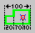
[F7] allows to visualize the graphic of the part and its toolings.

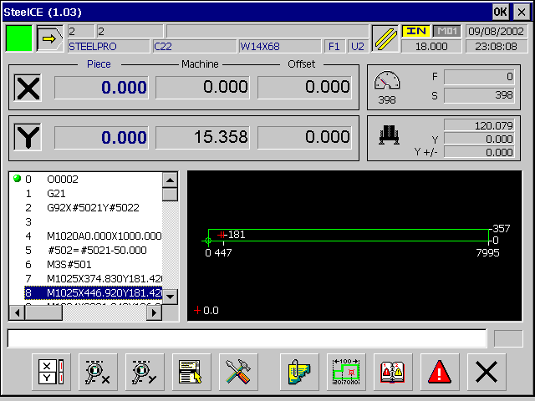
Execution Mode - Graphic

Alarms history



[F8] allows to visualize the historic of alarms.

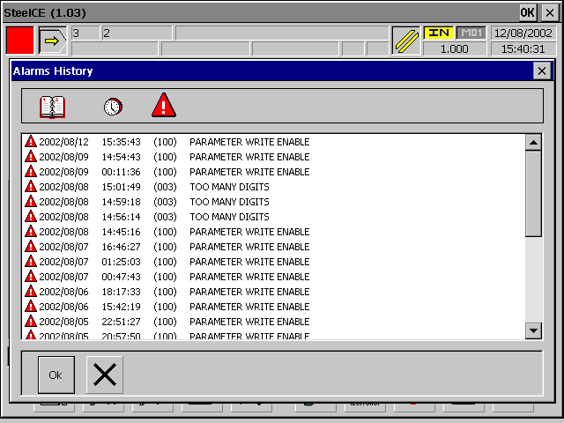
Execution Mode – History of alarms

Alarms



[F9] allows to visualize the current alarm.

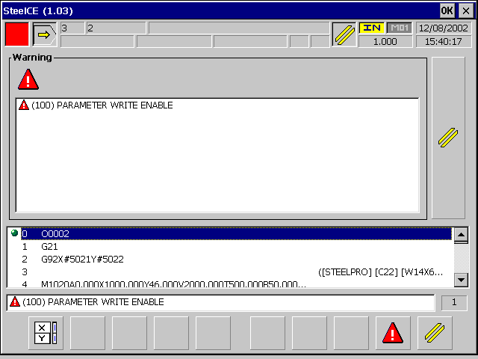
Ececution Mode – Current alarms


The button allows to reinitialize the alarms.

